**Title**

Aging & Society (200-level) SSDAN Quantitative Data Module

**Author(s)**

Marley Olson, Walla Walla Community College

**Learning Goals**

Make effective evidence-based arguments based on quantitative data and communicate relevant implications.

Develop increased confidence in understanding, evaluating, and doing social science research.

Cultivate self-efficacy strategies to sustain one’s intrinsic motivation for learning by developing a tolerance for and resiliency from learning challenges.

**Context for Use**

This module was developed for Aging & Society, a 200-level sociology course offered at an open admissions institution. It is also a required course for students in the Human and Social Services pathway.

**Description and Teaching Materials**

[Link]

**Assessment**

[Link]

In this module, students are introduced to foundational quantitative data literacy, including raw counts versus percentages, univariate table interpretation, and bivariate table interpretation. As a class, we walk through examples using WebCHIP with interpretation then generating our own tables. After the in-class workshop, students identify a research question and appropriate variables available in WebCHIP. The module culminates in brief student reports of their findings.

# SSDAN Quantitative Data Module

## Instructor Manual

### To prepare:

**Reserve a computer lab**. You will want to ensure there are enough computers for each student and that the space allows for a projector system. You will want to remind students ahead of this day to come prepared with their login information for your institution. Some students may want to bring in and use their own laptops; however, I assume all students will need a computer when reserving my computer lab space.

**Prepare your lecture**. I structure my instruction in the “I do, we do, you do” format and do not use any prepared visual aids other than the Student Worksheet, which we go through together with lecture interspersed between each section. I display the Student Worksheet through the projector, have a PowerPoint slide with PollEverywhere questions already embedded, and have a web browser open.

**Create a student engagement platform.** I use PollEverywhere embedded within a prepared PowerPoint that includes the True/False statements from the Student Worksheet. Alternatively, you might use Clickers or some other form of anonymous, synchronous student feedback system.

# SSDAN Quantitative Data Module

## Student Worksheet

### What will students do?

In this learning module, students will learn to distinguish between raw counts and rates to identify situations where each is most appropriate to use. Students will learn how to interpret bivariate tables, and then generate tables to answer their own research questions. Students will generate a suitable data visualization that effectively communicates their results and the implications of such to a lay audience in a two- to three-page report.

### What will students learn?

Student Learning Objectives (SLOs)

1. Discuss how the older population and the diversity of aging both affect and are affected by the social structure.
2. Make effective evidence-based arguments based on quantitative data and communicate relevant implications.
3. Develop increased confidence in understanding, evaluating, and doing social science research.
4. Cultivate self-efficacy strategies to sustain one’s intrinsic motivation for learning by developing a tolerance for and resiliency from learning challenges.

### Why this module?

This module provides the opportunity for students to see sociology as it is practiced to understand how we know what we know as opposed to only what is known. The main goal of this module is for students to learn about how knowledge is produced in the social sciences. Students will learn discipline-specific skills, methods, and techniques while gaining research experience. These skills are largely transferable and marketable for students in the labor market. Course-based undergraduate research experiences, like this one, have been shown to increase student engagement and foster more meaningful educational experiences.

### Instructions

About a week prior to the due date of the final report, as a class we will meet in Computer Lab 115 during our regularly scheduled class meeting time to work with the Social Science Data Analysis Network (SSDAN) WebCHIP online data tool. During this lab, students will become familiar with how to interpret bivariate tables and how to generate tables to answer their own research questions using the available data collections. Students will write a two- to three-page report that describes their research methods (including their research question, the data collection used, the dataset, their row and column variables, and control variables (if applicable)), their findings (including a data visualization and a written interpretation), and their recommendations based on theoretical and empirical evidence. The write-up should be two- to three- pages long. If any outside sources are used, they must be properly cited using any recognized citation style and include a bibliography/references page with full citations. Papers should be in Tahoma, Calibri, Helvetica, Arial, Verdana, or Times New Roman and 11- or 12- point font with 1" margins on all sides and double-line spacing. Write-ups should be submitted as a Word document or a PDF file. Microsoft Office is available to all students for download at no extra cost through our website [here](https://www.wwcc.edu/current-students/tech-services/wi-fi-e-mail-and-more/).

### Interpreting Descriptive Statistics

Collection: geo2016

Dataset: Earn

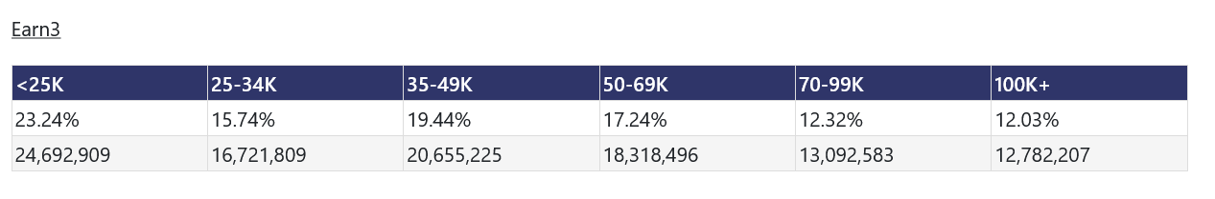

#### Earn3 Variable Definitions

<25K: Full-time, year-round workers age 16+ who earn less than $25,000 annually.

25-34K: Full-time, year-round workers age 16+ who earn between $25,000 and $34,999 annually.

35-49K: Full-time, year-round workers age 16+ who earn between $35,000 and $49,999 annually.

40-69K: Full-time, year-round workers age 16+ who earn between $50,000 and $69,999 annually,

70-99K: Full-time, year-round workers age 16+ who earn between $70,000 and $99,999 annually.

100K: Full-time, year-round workers age 16+ who earn $100,000 or more annually.

##### **Question #1:** Using the table above, how many (raw counts) full time, year-round workers who are 16 years old or older earned $100,000 or more in the U.S. in 2016?

Collection: geo2016

Dataset: AgeWork

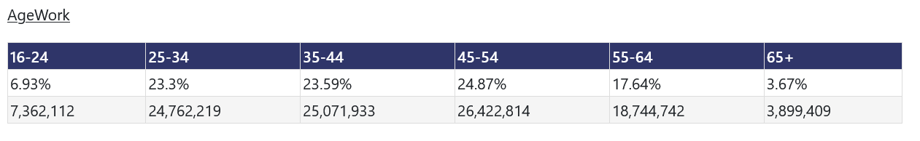

#### AgeWork Variable Definitions

16-24: Age of worker is between 16 and 24

25-34: Age of worker is between 25 and 34

35-44: Age of worker is between 35 and 44

45-54: Age of worker is between 45 and 54

55-64: Age of worker is between 55 and 64

65+: Age of worker is 65 or older

##### **Question #2**: Using the table above, what percent of workers in the U.S. were 65 years old or older in 2016?

Please participate in the PollEverywhere activity now to check our learning!

1. Almost 25 million full-time, year-round workers age 16 or older earned less than $25,000 in 2016. [True / False]
2. About 25% of workers were between the ages of 45 and 54 in 2016. [True / False]

##### **Question #3:** What is the difference between raw counts and percentages?

##### **Question #4:** Why would we use raw counts sometimes and percentages in other cases?

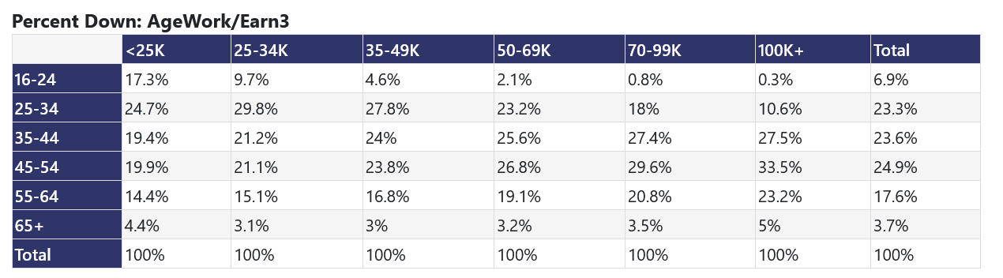

Sample Interpretation #1: Of those full-time, year-round workers age 16+ who earned less than $25,000 in 2016, 17.3% were between the ages of 16 and 24 years old.

Sample Interpretation #2: Of those full-time, year-round workers age 16+ who earned $100,000 or more in 2016, 5% were 65 years old or older.

##### **Question #5:** What percent of those who earned between $35,000 and $49,999 in 2016 were between the ages of 35 and 44 years old?

##### 

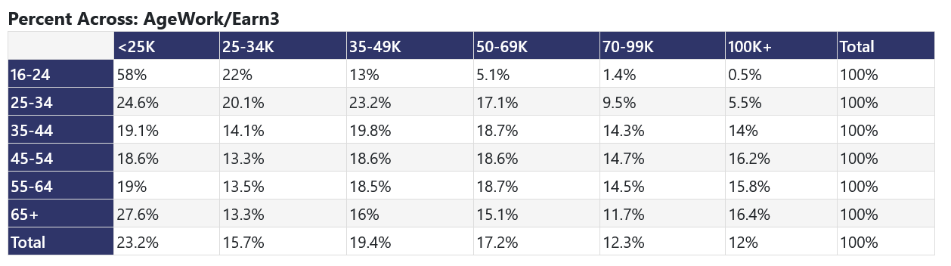

Sample Interpretation #1: 58% of workers aged 16 to 24 years old earned less than $25,000 in 2016.

Sample Interpretation #2: 16.4% of workers age 65 and older earned $100,000 or more in 2016.

##### **Question #6:** What percent of those between the ages of 35 and 44 years old earned between $35,000 and $49,999 in 2016?

Please participate in the PollEverywhere activity now to check our learning!

1. 4.4% of those 65 years old or older earned less than $25,000 in 2016 [True / False]
2. 24% of those who earned $35,000 - $49,999 in 2016 were between the ages of 35 and 44 years old. [True / False]

### DIY Activity!

Go to <https://ssdan.net/datacounts/webchip/>

Collection: acs2016trend

Dataset: Elderly

Here is a link to the variable glossary: <https://ssdan.net/variable-glossary/> You will need to identify the two variables available in this dataset that would have the information you need to answer the question below.

##### **Question #7:** What percent of elderly (i.e., 65 years and older) female respondents were widowed in 2016?

##### **Question #8:** Let’s make a data visualization! Can you represent your findings as a bar chart?

### Original Research Project Assignment

Now that you’re feeling comfortable with both interpreting and producing bivariate tables using the WebCHIP data tool from SSDAN, let’s do our own research projects! You are welcome to sift through all of the existing data collections and data sets for variables related to our course topic. Alternatively, at the end of this packet, I’ve developed a list of potential interesting variables if, like me, you get overwhelmed by so many data collections and the lacking infrastructure to help you easily and quickly navigate the WebCHIP system.

#### What collection will you be using?

#### What data set will you be drawing from?

#### What is your row variable?

#### What is your column variable?

#### Will your percent be totaling across or down?

#### Are you including any control variables? If so, which?

#### Generate a table. Be sure to save or copy this down as you will need it for your final write-up.

#### Generate a data visual (e.g., bar, pie, line, stacked bar). Be sure to save or copy this down as you will need it for your final write-up.

#### Interpret your results (i.e., tell a story about the numbers using words).

#### Offer explanations based on what you’ve learned in class and any other outside research from scholarly or government sources (remember to cite!) about why we might see these trends (said differently, what are some likely explanations for why these social patterns occur).

#### Based on the trends and the theoretical framework you created above, what are the implications of these findings? What would you recommend based on these results? Is any action needed? If so, what? If not, why?

### SSDAN WebCHIP Data Ideas

Collection: acs2016trend

Dataset: educ

Row: age

Column: educ

Collection: acs2016trend

Dataset: educoccup

Row: wkage

Column: educ

Collection: acs2016trend

Dataset: poppov

Row: agepov

Column: sex

Collection: acs2016trend

Dataset: popstruc

Row: period

Column: age

Collection: geo2016

Dataset: Earn

Row: Earn3

Column: AgeWork

Collection: acs18_5yr

Dataset: ElderDisab

Row: SelfCare

Column: PovLevel

Collection: acs18_5yr

Dataset: INDLVLMT

Row: SelfCare

Column: PovLevel

Collection: acs21_5yr

Dataset: PopUSA

Row: AgeAll

Column: RaceEth

Control: Sex