SYG2000 Introduction to Sociology
Class Reflection 3
Table 1 - 2016
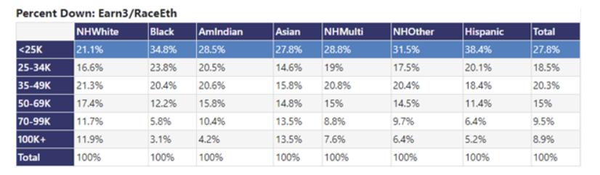

Table 2 – 2008
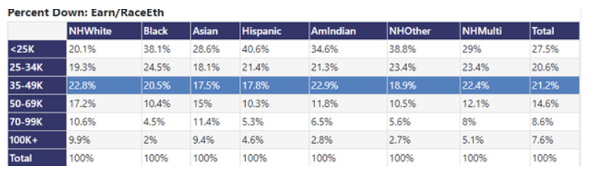

Earning Distribution by Race
In 2008 the highest percentages for those earning 25k or less in the race category included Hispanics, NH other, and Black with the highest percentage. In comparison, the races earning 100k or more included Asian, White and NH Multi. Looking at the chart as a whole the most people are making 25k or less and the smallest percentage is making 100k or more. The median for this chart was those earning between 35-49k for all races. From these categories it is important to note that regardless of race, women would be making 75 cents on the dollar to their male counterparts. There are also more specific factors like what ethnicity an individual identifies as. Only 2% of Black individuals make 100k or more.
Changes from 2008- 2016
In comparison to 2008, in 2016 for those earning 25k or less in the race category did not change with Hispanics, Black and NH other leading these percentages. A slight negative change occurred where Blacks are slightly more represented in this low-income category and Hispanics slightly lower and doing slightly better in this category. Leading the 100k or more category in 2016 is still NH White, Asian, and NH Multi. The only significant difference is that now they are taking a bigger cut of the pie by at least 5% than in the previous 2006 tally. The median is a slightly higher percentage of individuals. Also compared to 2008 now only 3% of Black individuals make 100k or more, which is only up one percentage in since the previous 8 years.
Florida’s Race History
The state of Florida has a history of Slavery and racism, it also home to many immigrants from Mexico, South America and notably Cuba. The economic structure for Mexicans immigrating to Florida would be different than that of a Cuban because of the trade and level jobs that were often occupied by Mexicans whilst Cubans who were college educated would take higher paying jobs. Florida itself is not racially diverse only south Florida is (primarily Miami-Dade and Broward County). South has also become too expensive for its residents who work there to live there any longer.
Personal Economic Inequalities Observations
The data I analyzed rings true to the realities of racial and economic inequalities. As long as people who do not look like you are in power controlling the majority of the capital there will beno significant change in years to come. I do not have a personal experience with wage disparity and inequalities and neither does my family however that does not discredit the stories of others and the hardships they have had to face. We have made strides as a nation to raise awareness about these inequalities. However, lasting change doesn’t seem to happen for many no matter who the elected official is. The charts depicted over the span of eight years the rich getting richer and the poor getting poorer. I fear this divide will only grow even in developed countries.

